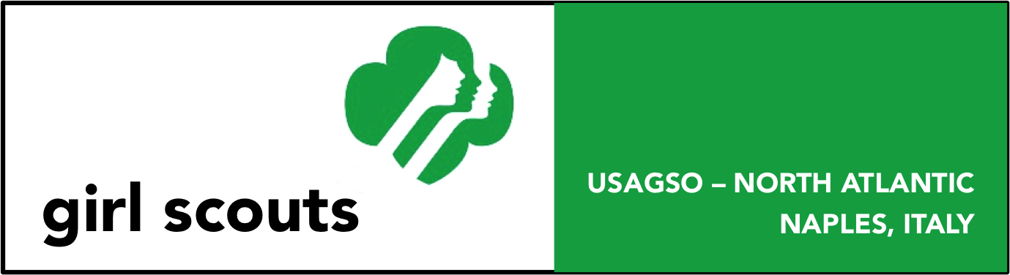

Mozzarella di Bufala - Naples, Italy
(All Levels)
Description: Mozzarella di bufala (buffalo mozzarella) is a traditional Italian cheese made from the milk of the water buffalo. In Italy, it is produced under strict regulations and is mainly produced in the Campania, Paestum, and Foggia regions. There are farms around the Campania region that are open to tours. One that is easily combined with a Paestum tour is Tenuta Vannulo. ( http://www.vannulo.it/contatti.php?lang=en )

- This patch may be earned by participation as an individual or in a troop. Please follow Safety Wise when planning your outing.
- The patch may only be earned by currently registered girls.
- The patch is not official insignia. It may be worn on the back of the sash or vest.
- The cost is $3.00 per patch.

To earn this Badge:
- Daisy: Must complete tour of mozzarella farm (Step 2), complete one activity from each of the other steps.
- Brownie: Must complete tour of mozzarella farm (Step 2) and Step 1 (Learn new facts), also pick two other steps from which to complete one activity from
- Junior: Must complete Steps 1 (Learn new facts) and Step 2 (tour). Also pick one activity from the three other steps to complete one activity from.
- Cadette: Must complete Steps 1 and 2 and 4. Pick one activity from steps 3 and 5 to complete.
- Seniors / Ambassadors: Must complete Steps 1, 2, and 4. Pick two activities from steps 3 and 5 to complete
Purpose: When I’ve earned this badge, I’ll know how mozzarella di bufala is produced will be able to relate its production to the local area.

Steps:
- Learn new facts about mozzarella di bufala
- Take a tour of a farm
- Taste and experience
- Relate to the regional culture
- Share what you have learned

Step 1: Learn new facts
- Research facts about water buffalo, share these facts with your troop
- During your tour of the farm listen carefully and make a list of 3 new things you learned
- Draw a picture of something you learned about buffalo

Step 2: Take a tour of a farm
- Organize a tour to a buffalo mozzarella farm
- Can you pick figure out how many steps it takes to get the milk from the buffalo till it becomes cheese? What are the steps?
- Talk about your observations during the tour with your troop or family. What was your favorite part?

Step 3: Taste and experience
- Sit down and taste some cheese. How is it similar or different to other types of cheese you may have had before?
- What other products can be made with the buffalo milk? Taste them as well if possible.
- Can you think of a recipe that would use a buffalo milk product? If you could make something with the product what would it be? If possible, go home and make it with your family.

Step 4: Relate to the regional culture
- Each country has their traditional foods. Mozzarella di bufala is a traditional food of Italy. Find any information about how long Italy has been producing this cheese or where the first buffalo in Italy came from. What were the buffalo first used for before being used to produce milk?
- Many farms are generational, meaning they have been run by a family for possibly hundreds of years and each new generation takes on the family business. Are there any skills or stories in your family that have been passed down from older generations?
- Where is your family from? What are traditional foods of your ancestors?

Step 5: Share what you have learned
- Draw a picture of your favorite part of the tour and share it with your troop.
- Write a letter to a family member or friend about your experience.
- Make a dish using the cheese or buffalo milk with your family.

Resources:
http://www.lucianopignataro.it/a/vannulo-di-antonio-palmieri-luomo-che-parla-alle-bufale/60551/
http://www.nytimes.com/2012/10/14/magazine/buffalo-mozzarella-craigramini.html?pagewanted=all&_r=0
http://en.wikipedia.org/wiki/Buffalo_mozzarella

Please send the completed order form and a check or money order to:
USA Girl Scouts Overseas – Naples
Attn: Patch Coordinator
PSC 808 BOX 6
FPO AE 09618-0001

Mozzarella di Bufalo Order Form
Overseas Committee/Council_______________ Troop #_____________ Troop Level:_________________
Please list activities completed:

__________________________________ _______________________ _______________
Printed name of adult certifying completion Signature of certifying adult Date completed
Please make check or money order payable to USA Girl Scouts Overseas – Naples
Mailing address for patch:

Contact name
Phone # (incl. country code): _________________________ email: _______________________________

