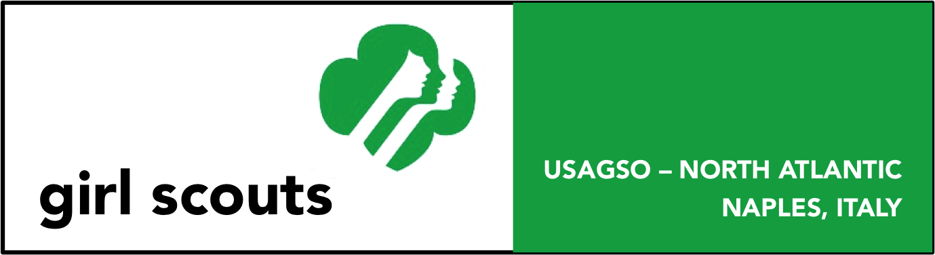

Exploring Volcanoes - Naples, Italy
(All Levels)
Description: Naples, Italy is the the site of one of the most famous volcanoes in the world, Mt Vesuvius. Learn more about this volcanoes by completing this badge.

- This patch may be earned by participation as an individual or in a troop. Please follow Safety Wise when planning your outing.
- The patch may only be earned by currently registered girls.
- The patch is not official insignia. It may be worn on the back of the sash or vest.
- The cost is $3.00 per patch.
To earn this Badge:
- Daisies complete at least 4 of the following activities.
- Brownies complete at least 5 of the following activities.
- Juniors complete at least 6 of the following activities.
- Cadettes complete at least 7 of the following activities.
- Seniors complete at least 8 of the following activities.
- Ambassadors complete at least 9 of the following activities.
- Take a field trip to at least one of the following sites:
  - Mt Vesuvius
  - Sulfatar
- After your trip, discuss with your Girl Scout troop what was your favorite part of the trip, two facts that you didn’t know before you went and anything else that you would like to share.
- Camp at Carney Park
- Find out about how the structure of Carney Park affects its weather.
- Draw a timeline to show the known eruptions of Mt. Vesuvius
- Make a collection of different types of rocks formed by volcanic activity. Label your samples and briefly explain how they were formed.
- Create a booklet to explain Mt. Vesuvius to other (younger) Girl Scouts. Be sure to include how the mountain got its name, how often it has erupted, and how a volcano works. Make sure to use diagrams, photos, and drawings to illustrate your booklet.
- Make an earthquake kit for your home. Be sure to include items that would be needed in case a major earthquake struck your community. Information on earthquake kits is available through the American Red Cross.
- Create a picture collage of volcanoes using magazines, Internet sources, or newspapers.
- Invite an expert on volcanoes or earthquakes to speak to your Girl Scout troop. Ask the speaker to talk about our local geology and how our community is preparing for the next eruption or earthquake.
- Learn about the emergency broadcast system in your city or town. Then create a mock broadcast about an eruption or earthquake of Mt Vesuvius. Include information about what happened, and how people need to handle the situation to make sure they are safe.
- Interview a family member or friend that has been through a natural disaster such as an earthquake, eruption, tornado etc. Try to video or audiotape a copy of this interview to share with others.
- Make up a song for younger girls outlining the safety tips about what to do during a natural emergency such as an earthquake.
- Write a story about a girl who found herself caught in an earthquake. Focus on character and plot and illustrate your story. Read this story to a group of younger girls.

We would like to acknowledge that we borrowed many of these steps from Girl Scouts of Oregon and Southwest Washington and their Patch for Mt St. Helens. http://www.girlscoutsosw.org/Files/Program/Patch%20Programs/Mt_Saint_Helens-jrs.pdf

Please send the completed order form and a check or money order to:
USA Girl Scouts Overseas – Naples
Attn: Patch Coordinator
PSC 808 BOX 6
FPO AE 09618-0001

Exploring Volcanoes Badge Order Form
Overseas Committee/Council_______________ Troop #_____________ Troop Level:_________________
Please list activities completed:

__________________________________ ________________________ ______________
Printed name of adult certifying completion Signature of certifying adult Date completed
Please make check or money order payable to USA Girl Scouts Overseas – Naples
Mailing address for patch:

Contact name

Phone # (incl. country code): _________________________ email: _______________________________

